Test Case: tc002_SPX_Dev5_Crear_Requisicion_Spot_Tipo_Cobro_Project
Step 1 - Enter username and password and click to button Enter: Credentials Entered
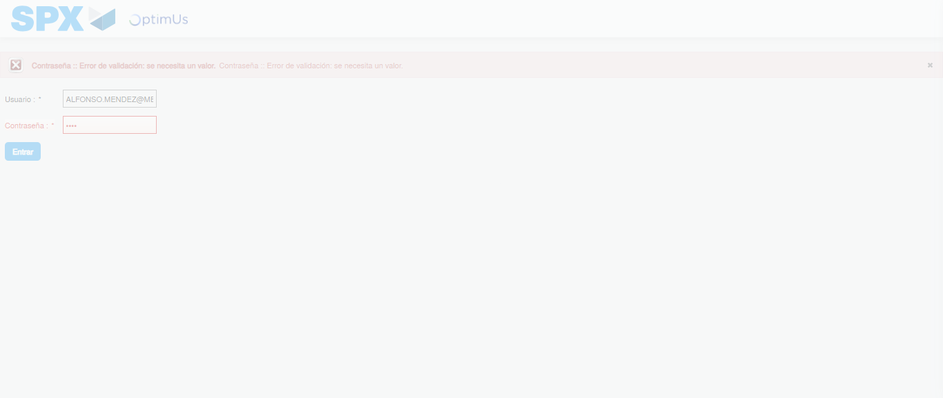Image file-name: QC_Testing-tc002_SPX_Dev5_Crear_Requisicion_Spot_Tipo_Cobro_Project-1783378429564

Step 2 - Select to UEN and Access to Spot Buy Requisitions : UEN Correctly selected and Correct access
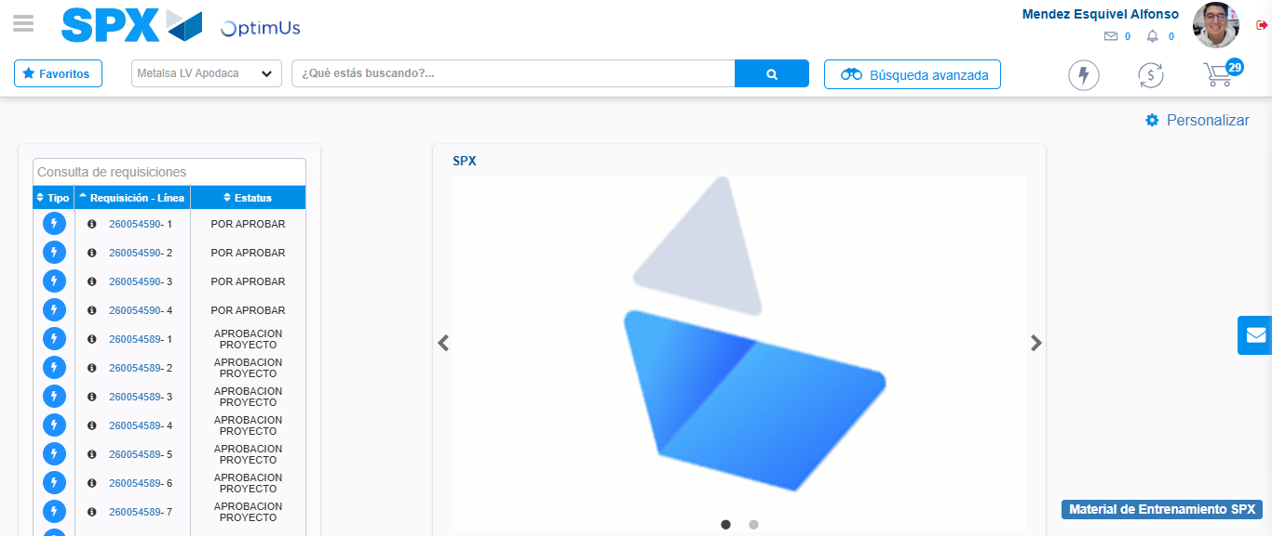Image file-name: QC_Testing-tc002_SPX_Dev5_Crear_Requisicion_Spot_Tipo_Cobro_Project-1783378454980

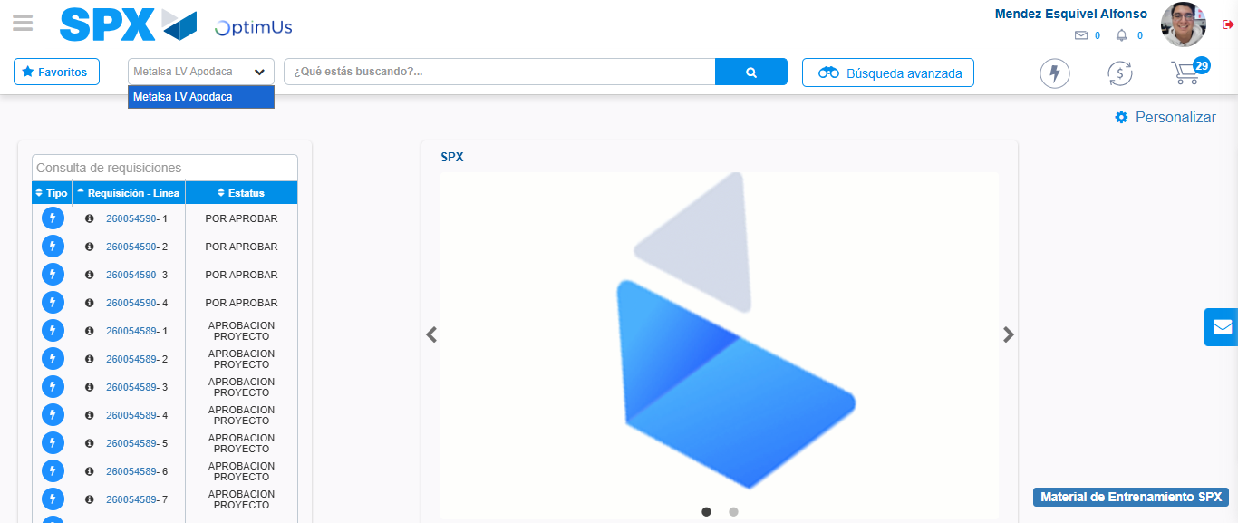Image file-name: QC_Testing-tc002_SPX_Dev5_Crear_Requisicion_Spot_Tipo_Cobro_Project-1783378457455

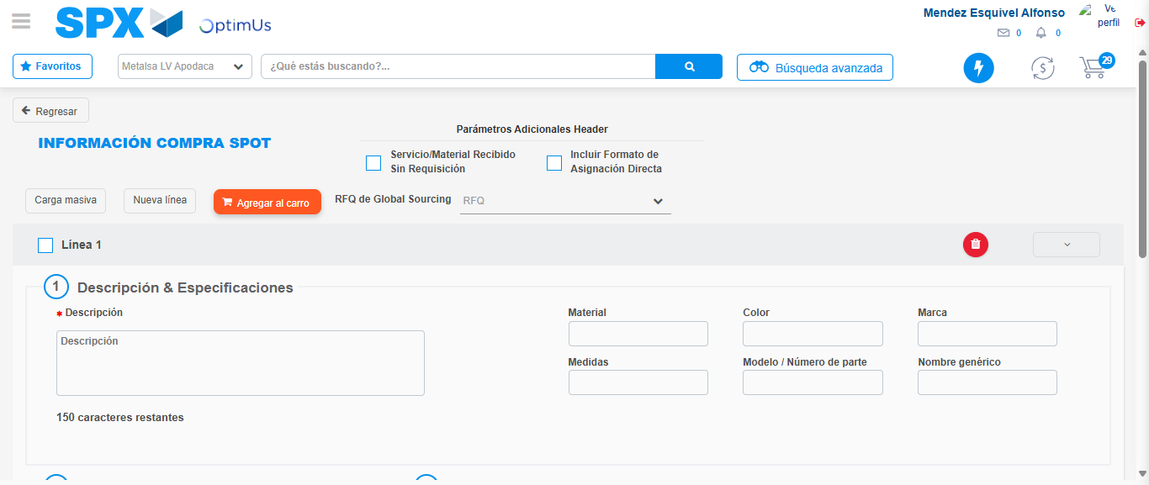Image file-name: QC_Testing-tc002_SPX_Dev5_Crear_Requisicion_Spot_Tipo_Cobro_Project-1783378477531

Step 3 - Data Capture Spot Buy Requisition: Data captured correctly
Image file-name: QC_Testing-tc002_SPX_Dev5_Crear_Requisicion_Spot_Tipo_Cobro_Project-1783378477747

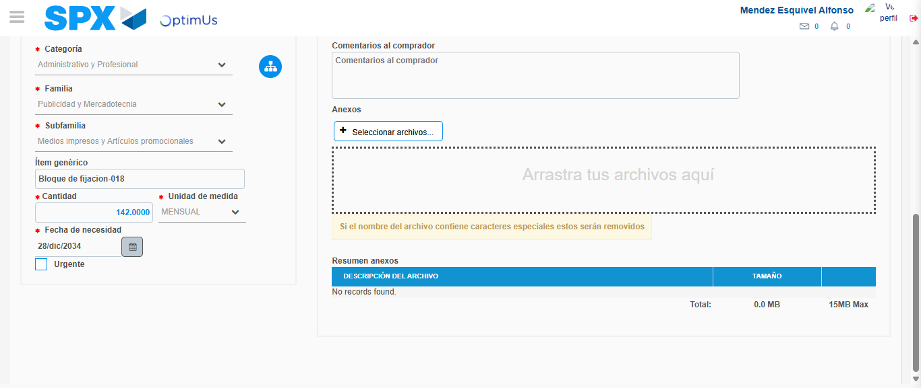Image file-name: QC_Testing-tc002_SPX_Dev5_Crear_Requisicion_Spot_Tipo_Cobro_Project-1783378487495

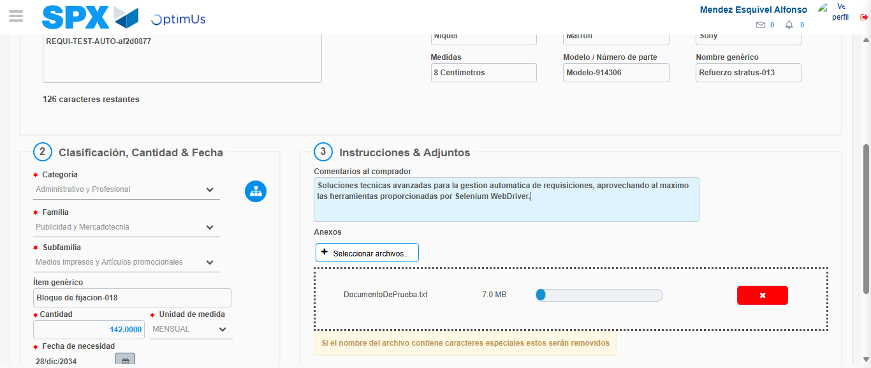Image file-name: QC_Testing-tc002_SPX_Dev5_Crear_Requisicion_Spot_Tipo_Cobro_Project-1783378488309

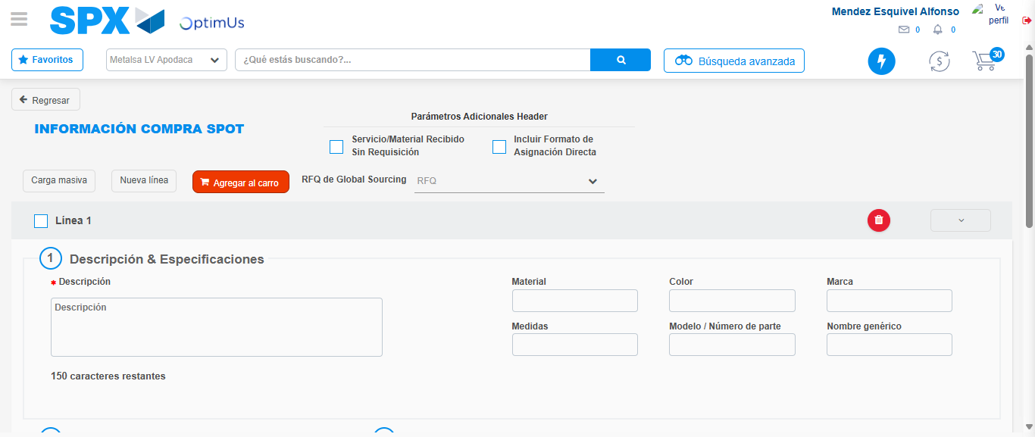Image file-name: QC_Testing-tc002_SPX_Dev5_Crear_Requisicion_Spot_Tipo_Cobro_Project-1783378495728

Step 7 - Return to Main Page SPX : Return to Main Page SPX
Image file-name: QC_Testing-tc002_SPX_Dev5_Crear_Requisicion_Spot_Tipo_Cobro_Project-1783378454980

Image file-name: QC_Testing-tc002_SPX_Dev5_Crear_Requisicion_Spot_Tipo_Cobro_Project-1783378457455

Image file-name: QC_Testing-tc002_SPX_Dev5_Crear_Requisicion_Spot_Tipo_Cobro_Project-1783378477531

Image file-name: QC_Testing-tc002_SPX_Dev5_Crear_Requisicion_Spot_Tipo_Cobro_Project-1783378497948

Image file-name: QC_Testing-tc002_SPX_Dev5_Crear_Requisicion_Spot_Tipo_Cobro_Project-1783378498118

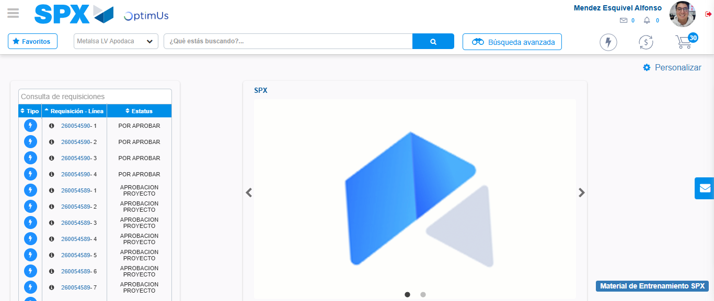Image file-name: QC_Testing-tc002_SPX_Dev5_Crear_Requisicion_Spot_Tipo_Cobro_Project-1783378519228

Step 8 - Log Out : Log Out SPX
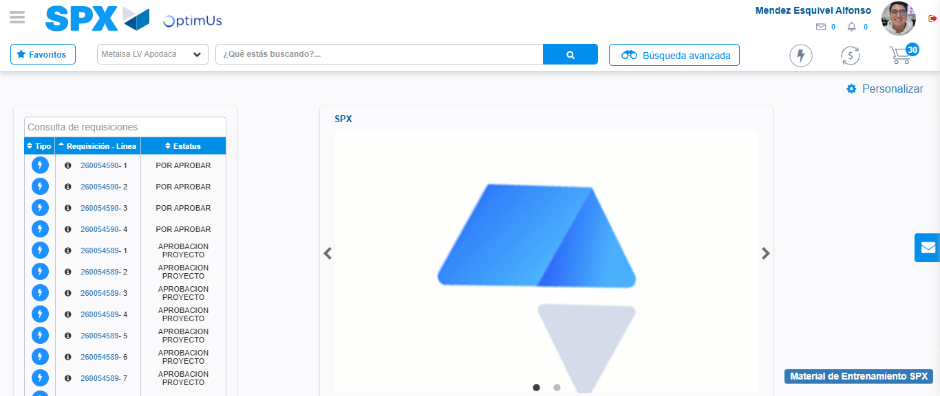Image file-name: QC_Testing-tc002_SPX_Dev5_Crear_Requisicion_Spot_Tipo_Cobro_Project-1783378519444

